In this lesson Teacher is going to Teach us about How to code gravity with html canvas and javascript

As many of you know Gravity is a natural force that causes things to fall downwards towards the Earth if we hold a ball up in the air and let it go Gravity will take effective casing the ball fall down forward until it hit some sort of surface beneath it this explain how gravity works from a high level standpoint but its important that we also understand it from the technical side of things that is we were to translate this effect over to code from a technical standpoint the force of gravity causes objects to accelerate in a downward direction over time an objects can have varying velocities

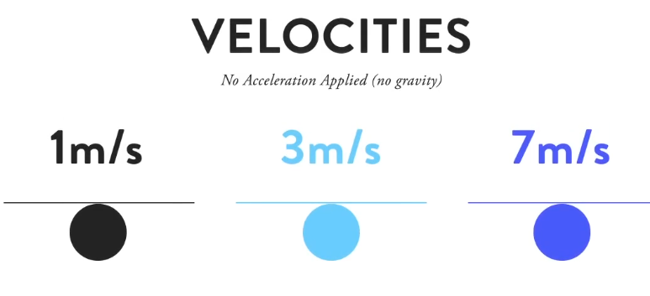

But if no force such as gravity is acting upon them the object don’t accelerate they move at a constant speed giving off the illusion of a linear motion however if we begin to increase our object velocity over time

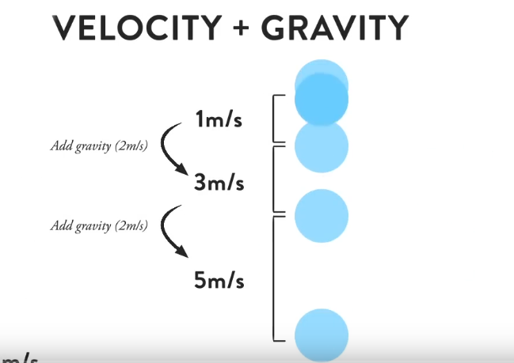

We are effectively creating the illusion of acceleration and if gravity is what causes objects to accelerate downwards over time well we just created the effect of gravity

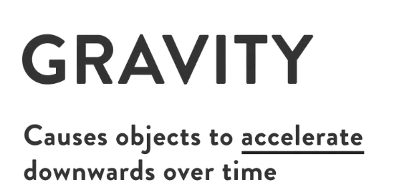

So gravity is the constant downward force applied to object velocities over time but to truly make it more realistic intriguing physics simulation we need to take into account what happens when a falling object hits the surface beneath it which is one the object will loose some of its energy due to friction

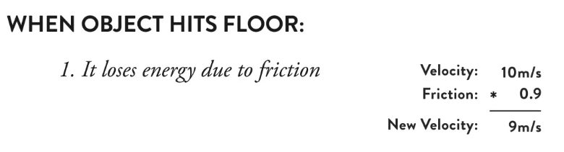

And the object y velocity reverses causing it to travel in the opposite direction

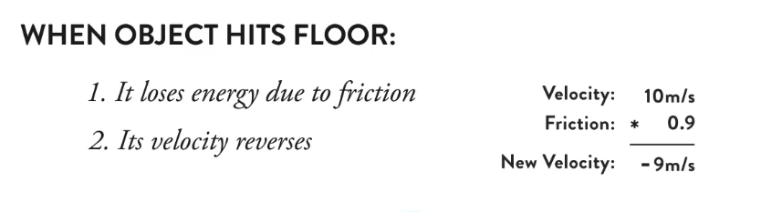

And with those concept in mind we should now be able to create a semi realistic gravity simulation as shown below



Now by coding Teacher will teach us How to create gravity with canvas and javascript .Lets start off from the very beginning lets go ahead and open a terminal window. Teacher has apple and I have windows and I have cmd. Now after opening cmd it look like below

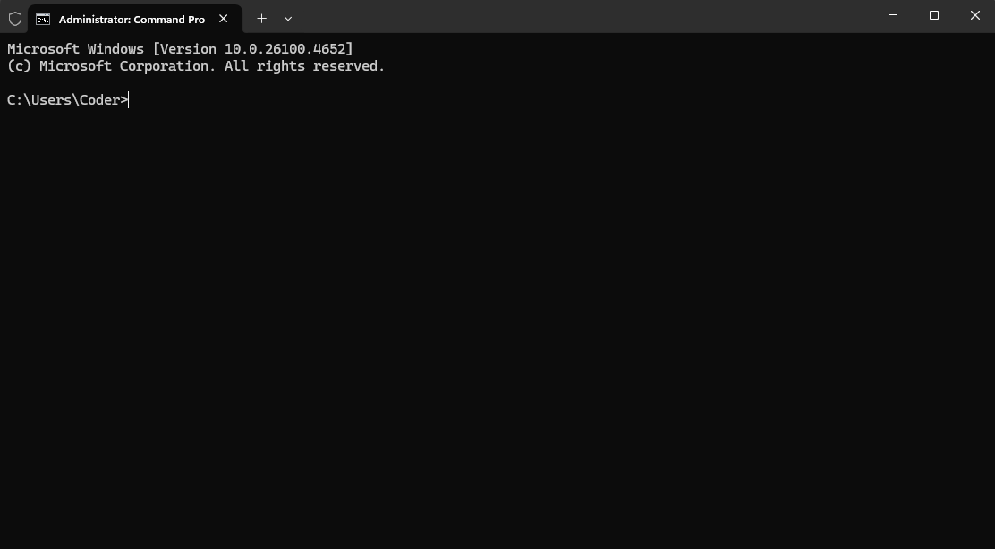

1:55

Cmd is like a file explorer whenever we open cmd then we are in the location shown above

By typing command dir we can see what is inside the foder we are currently in cmd

The reason we are using cmd is because it is a quicker way to do certain things on your computer and we are going to need it to run separate specific command in order to get started with this webpack project (who knows)

We use cd to change the directory to move to a directory where I like to code my project in so we have one folder so by doing cd cammands I reach my directory where I keep my project direcoty so i open cmd there as shown below

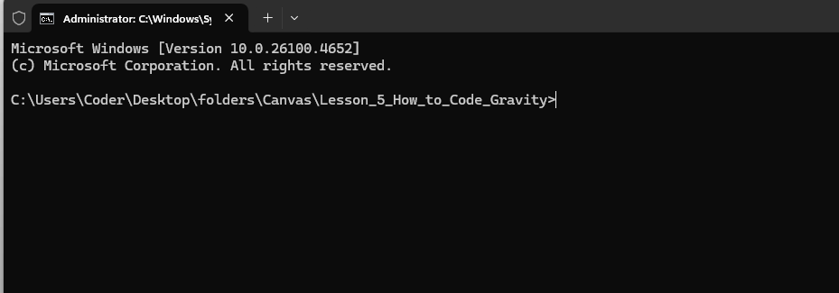

Now Teacher is saying us to clone a repository inside this folder and there is a repo that Teacher created for starting up on any canvas project basically it contains your typical index.html file

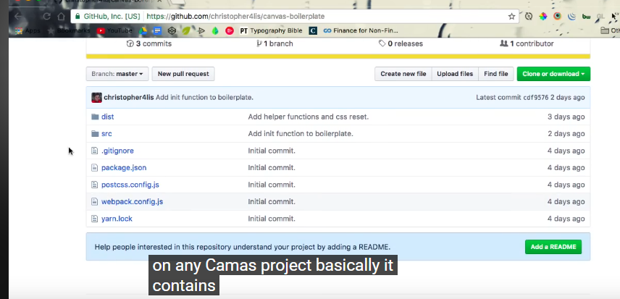

And also canvas.js file in src file for our javascript where we are actualy going to be writing our canvas code but it also contains few optimisation such as allowing us to write javascruipt using es6 allowing us to write CSS using SAS

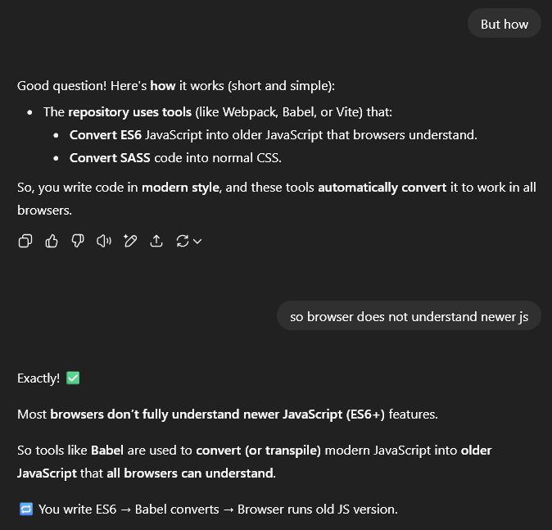

And it also refreshes our page automatically whenever we make a change to one of our files

We will copy the repository link and then type in cmd git clone

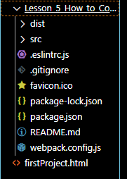

Now you can see we have successfully cloned the repository Teacher is mentioning by the cammand below



Now after the cammand we type the folder(inside the folder we are currently in) name where the cloned files will go

Now when you press dir then you can see there is gravity folder here

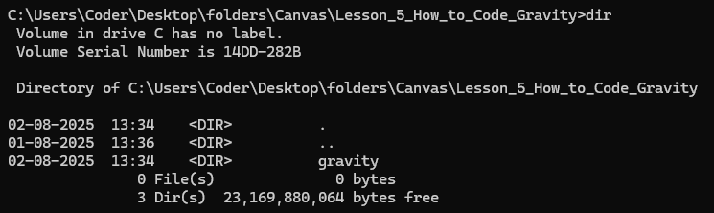

Iniside our folder for this lesson. It just contains all the files that we need in order to start with this canvas project So we are going to go ahead by going inside this gravity folder and now we need to do one thing before we actually get started we open it in our favourable editor we open it in VS studio code and in order to start with our project we need to download all the dependencies within our package.json file

4:11

Basically these are all the things we need in order to make use of all those cool features Teacher was talking about such as automatic page refreshes and so forth (who knows).

So to install these we type npm install into the terminals or you can type cats if you have that downloaded as well(who knows) np and yarn are just package managers if you don’t have them downloaded at the moment Do a quick Google Search and search on hoe to download them and then type in just those command directly in the terminal of VS code Teacher preference is yarn because Techer find it faster than npm but which one you want to use is pretty much upto you . So I typed npm install inside the gravity folder and all the dependencies mentioned in package.json will be installed as shown below

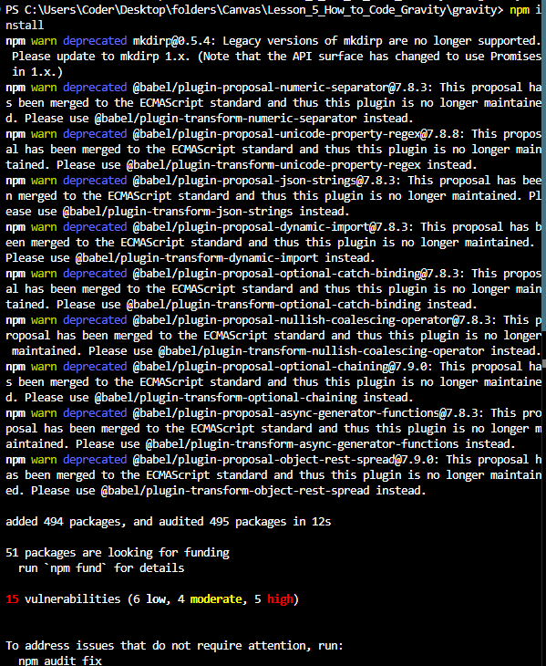

The yarn and npm both do the same thing So as soon as we install all our packages you will see now we have folder for node modules as marked below

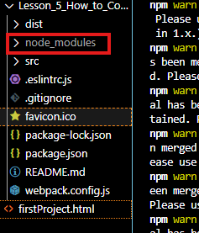

And to actually running up in our terminal we are just going to type webpack but it is now working because this lesson is old so in new way I add this below

"scripts": {

"build": "webpack",

"watch": "webpack --watch"

}

In package.json

And you can type the command

**npm run build**

**npm run watch**

then you can see that you can see your websote live

as shown below

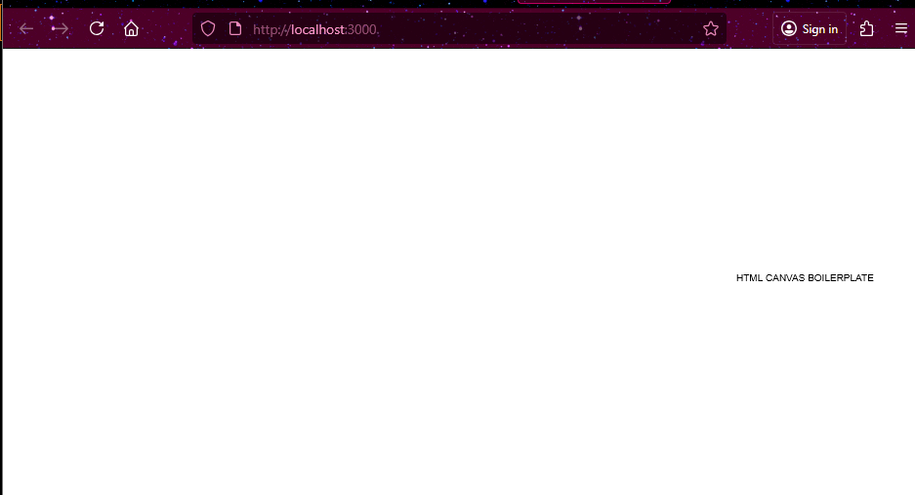

In localhost:3000

4:56

And what do we know it just happens that this page has a canvas that extends the full width and height of the browser as we learned about how to do within our HTML5 canvas course for beginners Now in src>js>canvas.js this as shown below

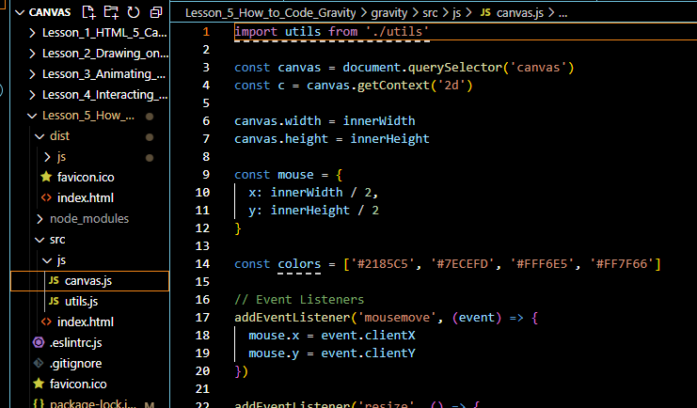

Now this is a bunch of template code that we use within pretty much every canvas project that we end up coding so this contains things that we have already gone over within html 5 canvas course for beginners so you can we have code such as automatic browser resizing we are tracking our mouse positioning we have event listener the only thing that’s different here really are these two (in older code but not in new)

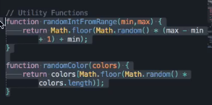

These are the utility function that make our canvas development that much simpler(who knows) rather than having to do bunch of Math.find random integer from a specific range this function will give it to you automatically you just have to input the minimum and maximum number and second function this will give you a random color as long as long as we put an array of color pass through it. Pretty helpful function we have

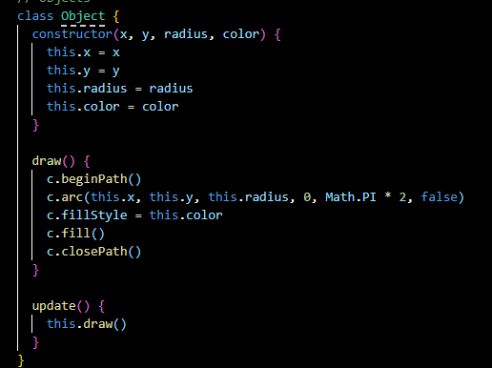

We have an outline of object that we will use later on and we also have animate loop

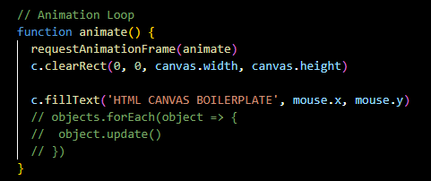

Which we will run pretty much over and over again until we tell it to stop

If we continue onward if we look within dist folder we have an index.html as shown below

Here Nothing you have not seen before we have a canvas tag and we also have a script which is linking in all the code in canvas.js

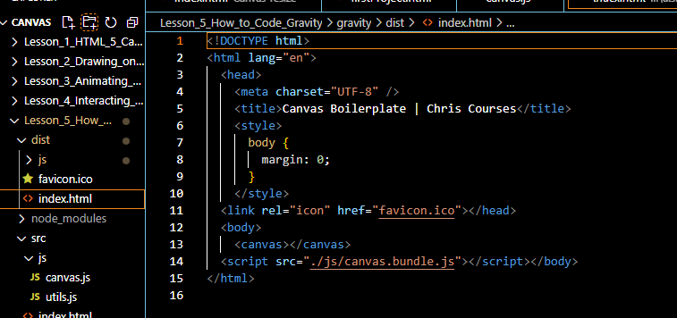

As long as our nom run watch is running in our background we should not have a problem start coding So to get started actual coding actual gravity the first thing we are going to do is create a circle in the middle of our screen and then we are going to be adding gravitational force to it so that when it drops it bounces back upward and keeps on getting pulling down as long as the gravity is in effect so to create a ball in the middle of our screen we are going to go ahead on over to our project and since this is where we are going to be calling this is a ball let replace the class name object with Ball as shown below

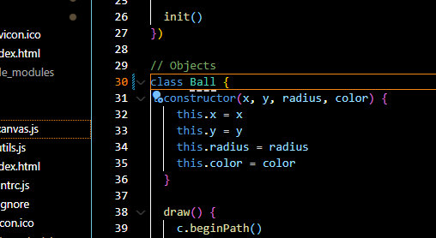

So we are going to be creating a ball and objects so later on we can actually create multiple ball because we need to make sure each ball has its own individual x and y coordinates as well as its own color and so forth so you will within this So you will see within draw function we are actually drawing out a circle. Which is perfect that’s exactly what we want we are using the arc function and we filling it in using c<canvas object>.fill . So to actually create a ball we have the outline for it in class Ball now

6:56

We need to make sure that we are instantiating it and to instantiate it we head over to our init function and inside we are going to saying var ball = new Ball() and this will go ahead and load all the values that we put into our ball function or in modern the new object of Ball we will create. So lets say we give lets give x of value width/2 and y value of height/2 and radius of 30 now for a color lets say it is red

Now our initialisation code inside init function look like below



Now we console log it out and make sure that we have a ball actually being loaded into the variable called ball

Now you can see it in our console as shown below

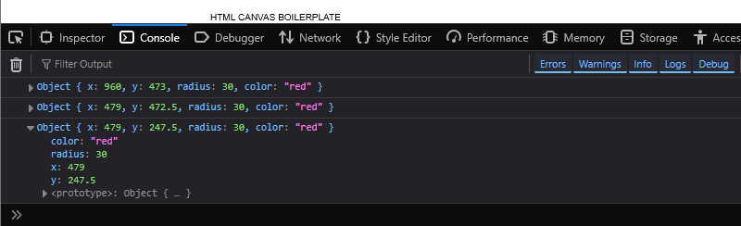

So now we just need to make sure we are drawing this out so we have our init function which is creating the ball but to actually draw this out we need to go inside our animate function and we need to make sure we are drawing it after the clearRect

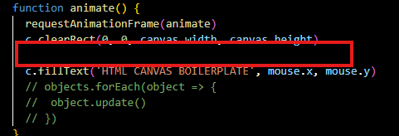

Otherwise lets see what happens when we don’t have a clearreact function in place when we don’t have this So I comment it then

When now we see the output then you will see the canvas is not being actually refreshed is actually never cleared each time we drawn on the screen as shown below



That kind of creates a cool effect but it’s not really what we are going for

8:06

We are going to animate a ball that falls down due to gravity so we need to make sure that we have this clearRect method and we need to make sure that we are calling the update method of Ball class as marked below

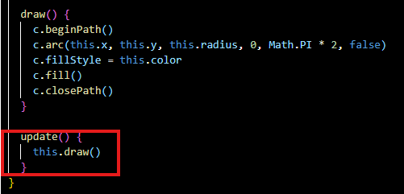

So we need to call this update method on the ball that we have created So we are going to go head and get rid if the text we are seeing repeatedly and now we are going to say ball.update() inside animate as marked below

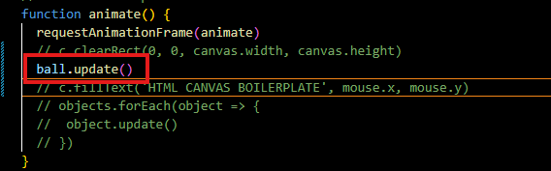

**Note:-**

To draw a text use fillText method of canvas

Now in output you can see the ball in red color as shown below

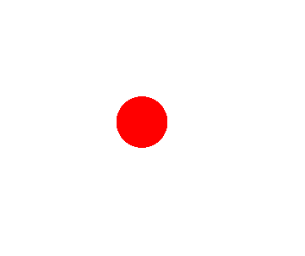

So what we need to do now is we need to actually add some gravity onto this ball’s y velocity so that when the ball starts falling downward it hits bottom and then it goes back upward gravity keeps on pulling on it and the ball will never keep on travelling upwards till it goes past the screen it will just keep pulling down by gravity so lets go ahead and change this ball’s y velocity .To change this ball’s y velocity we are going to head to our update function now we add the code this.y +=1 as shown below

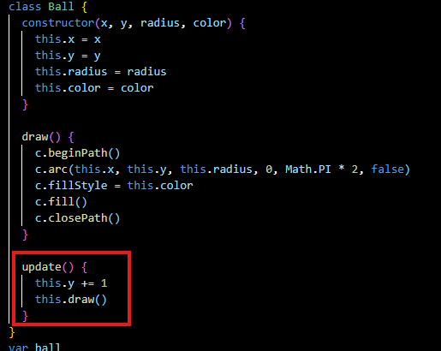

That going to be adding a velocity of one onto our y value as long as this update function keeps getting called over and over again So now after saving the file you will see the output below



Now you will see the ball slowly going downwards until it goes off the screen. So we don’t want it to go off the screen we want to make sure that’s its reversing when it hits the bottom of the screen so to add we need to add a conditional here that says if the ball’s y value plus the ball radius > canvas height that is equal to height of the screen then we want to reverse the ball’s velocity so in order to reverse this we need to make sure that we are declaring a variable this variable is called dy

10:07

Dy stands for vertical velocity so we declare this dy variable and it is being initialised by the parameter passed to the class o add the dy parameter in the class constructor now our class Ball look like below

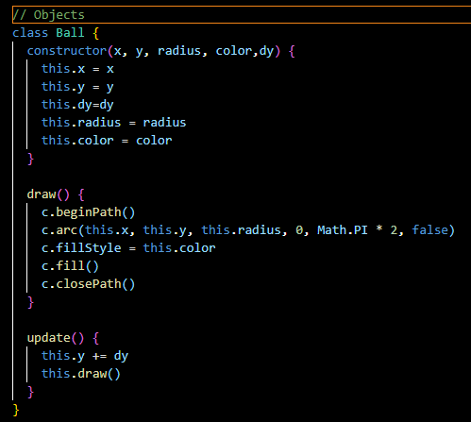

Now we pass the 2 argument for dy parameter in Ball class inside init function as shown below

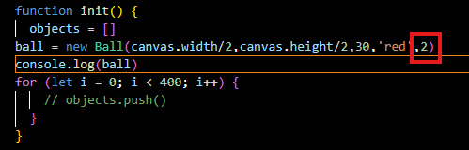

So now ou ball has a velocity of two and we are adding that onto our Balls current y

So now in update method we add condition such that this.y + this.radius > canvas.height hen we are going to be reversing this velocity causing the ball to go upward opposite direction So now our update method look like below

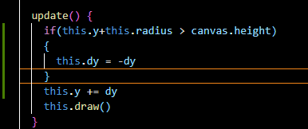

Si we we make our dy negative uinside the conditional

Now our output will look like below



So now the ball hit the bottom and bounce back and go in upward direction but don’t go downward but this without gravity applied as we mentioned within the intro we are currently adding a constant velocity onto our Ball’s y value this velocity is not actually changing at all we are not actually adding gravity onto it to ensure that its accelerating and falling downwards once it hits a certain point up here(maybe that is bottom of the screen) so to add gravity onto this we add an else to stimulate the effect of gravity

11:23

Its actually really simple al we are going to say is to add onto our current velocity a specific value Now our code look like below

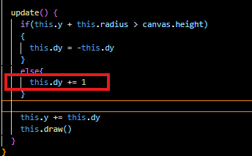

Now suppose we add a value of 1(maybe of gravity) as marked above



And now just like that we now have a gravity being added onto our ball and that’s really all there is to it we are creating acceleration with gravity in else block by adding a specific value onto our ball’s current y velocity so to help and visualize this a little better let’s go ahead and console.log our Balls y velocity and we will see what exactly Teacher mean

Now we console.log() our y velocity

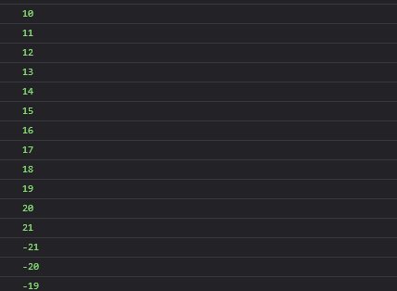

Now you can see in console that the velocity increases when the ball falls down and when ball reaches bottom the ball is fastest that is 21 and when it touches the bottom then the dy reverses and then ball goes upward

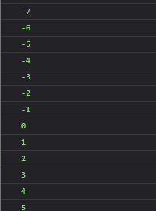

now you can see that the velocity is lowest at top that is 0 and then it start increasing again and the ball start moving downward and that’s going to give it the illusion of gravity basically So that is cool that we have gravity simulation here but its not a true physics simulation there are few things that we can do to make this little more realistic including adding friction onto this So to add friction onto this actually let start y changing 1 that we are adding to dy in else block by a variable named gravity just to describe our code what’s really happening here

Now our code look update method code look like below

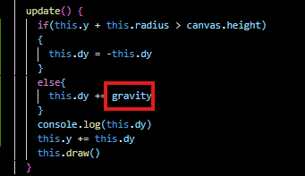

And we also declare gravity variable as global with value 1

13:34

And this is just for readability purposes we want to make sure that our code is readable and easy to understand if we ever come back to this and forget what really going on here so we have gravity added on our code but now we need to actually implement friction onto this ball so that the ball stops bouncing all the way back up because in a real world physics simulation the ball is going to lose its energy one it hits bottom of the screen and now to add friction onto this . Friction is basically its energy being transferred into the ground right here so we need to make sure that our ball velocity decreases each time ball hits the ground by a specific fraction so this fraction is going to be called friction and basically we are going to multiply our ball’s current y velocity by fraction such as 0.8, 0.9 and so forth as shown below

14:23

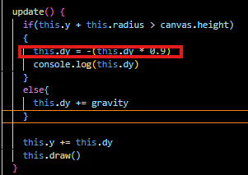

And closer this number is to 1 so the ball will bounce higher as compared to if we were change to change our friction to 0.2

So now our output look like below



In 0.5 friction the ball will bounce very low and will reach the surface very quickly and stays flat on the surface as it looses a lots of energy very quickly but lets go ahead and give it a nice little biouncy effect with 0.9 you will see that it takes a little longer for the ball to actually stop bouncing near the bottom of the screen which is pretty much the effect we want we may even want to go higher kind of make sure that our ball bouncing for a good period of time and Teacher is goin to stick with 0.99 for friction because its going to make our gravitational effect look that much cooler once we actually get to more and more ball to the screen do our friction is going to 0.99 for time being we replace the hardcode 0.99 with the variable friction and we declare it as a global Now our update code look like below

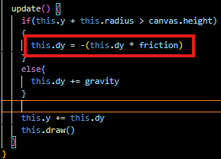

So as we know the ball eventually loses velocity the more it hits the bottom of the screen as we have the effect of gravity with one bouncing ball but to make this a visually interesting canvas piece we can take this one step further lets go ahead and create multiple balls in the process. So to create multiple balls we are going to be creating an array near implementation section the is above the init called ballArray as shown in the code below

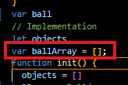

Basically this is going to contain all the balls we are going to be using within our simulation and eventually we are going to be accessing them one by one within the animate function through loop and we are going to be drawing them in different direction and randomize velocities and so forth and it’s going to give us a nice randomized really interesting feel in the process so we are going to be creating a ball array and we need to actually get objects within this ball array so to do that within the init function we are going to create a for loop

I don’t know what teacher is saying so ignore somethings so we add the condition for “for” loop such it runs 500 times So our init function code look like below

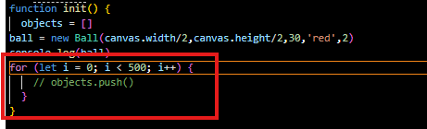

16:32

So this represents the number of balls that we want to draw on the screen but now we need to actually get some balls within this ballArray so to do that we are going to say ballArray.push and inside it we pass the new objects if class se specify x,y position and dy and also radius sd well as the color do rather than giving them all tyhese same x and y coordinates lets go ahead and randomize them to randomize these coordinates we are going to be creating a variable each time we run through the for loop

So to generate and random number we have a helper function in the code as shown below

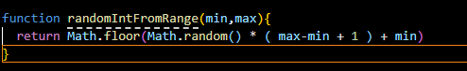

And we will use this function and create a random number and store it inside a variable every time we run through loop so we declare x variable inside our loop so x gonna be a random integer and lets just start off with some zero to canvas width so the helper function going to be storing that within x variable but now we need to pass it inside our new ball object x argument so lets just start of with a value of 100 for y position and our dy positional argument will be equal to 2 and radius will be 30 and then we set the color red for the time being Now remove the Ball initialisation code outside the loop for the previous we created for demo as marked below

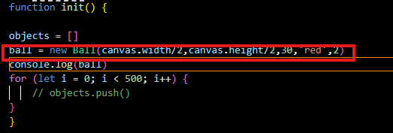

And also make sure you also remove the code associated with the ball in animate function as marked below

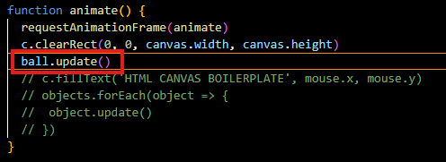

So if we say we are not seeing anything in the output

Now our init method look like below

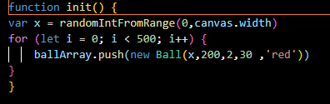

Now we console.log out out ballarray after our loop to make sure things are actually being created within this init function as marked above

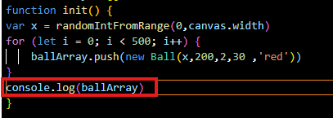

18:01

And is we look within this console you will see the console

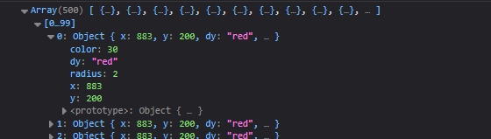

There are 500 ball objects each having different x values so we are creating balls in random locations over here we just need to animate the balls we created on the screen now so to animate them we are going to make another for loop inside this animate and it will start from 0 to ball array. length so that we can go through each ball in the array if we change the length of the array in future so since array length is 500 so our loop will run 500 times each time this animate function is being called but now we need animate each individual ball so to animate each individual ball we are going to be selecting our ball and then we need to access each individual one using the ball arrays index so with the help of the index we will select every single ball for us as long as this for loop is being run so what we can do is update

So now our animate method look like below

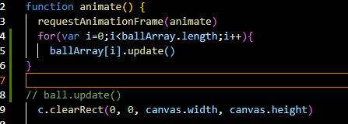

Now if we save then we did not see anything this is because we are actually trying to draw all our balls before actually clearing our canvas so let place thee loop after clearReact

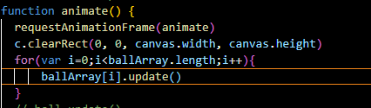

19:45

Now as soon we do that we see below



Now in above you can see a long line just bounce the bottom of the screen that is because all our ball has same y positioning due to which they pretty much look like one giant strip going on above so lets go ahead and randomize our y positioning as well so we do the same with y like we did with x but now instead of getting a random value from 0 to the canvas width we want to make sure that we are getting a random value from 0 to canvas height and now inside this y value into our instantiate object inside the loop so lets go ahead and do that Now our init method look like below

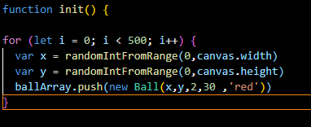

Now our output look like below



it is looking a lot better then it was before you can kind of make out the balls nit it is still kind of hard do because we don’t actually have a stroke they are kind of colors that are kind of merging in together do lets go ahead and add a stroke on our circles so we add stroke method and also linewidth of 3 in our draw method that is responsible for drawing our ball SO the draw method look like below

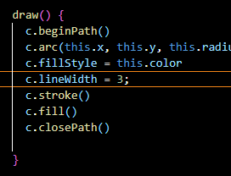

Now our output look like below



Now it is looking a looking a lot cooler or better looking but we are having still some issues here You can notice some balls are caught on the bottom of our page and a few of them well if we want to add x velocity onto this well they are going to go off the screen which we will see in second so lets go ahead

21:08

And make sure these things are not getting stuck on the bottom. The reason they are stuck on the bottom because our randomization helping function is spawning our ball so that the edges are actually got caught on the bottom of the screen we want to make sure that we are only spawning the balls away from the radius to zero.



And that going to prevent them we are getting caught down here like they are right now. So instead of getting random coordinate from 0 to canvas height we will get a random coordinate

Now we subtract the radius from our canvas.height in random function argument part and instead of hardcoding it we declare a variable radius inside the init function and we replace 30 with radius in initialisation of the Ball class Now our init function code look like below

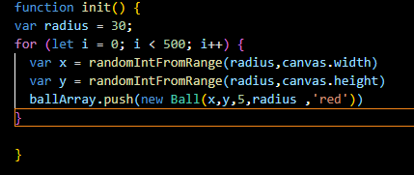

22:08